* String : -

|  |  |
| --- | --- |
| String | String Buffer |
| String object are immutable(Not changeable) | String buffer are mutable (changeable) |
| Example  Public void class test{  String s = new String(“Aniket”);  s.concat(“Nangare”);  sop(s);  }  OP – Aniket (because one object created but not assign reference variable) | Example  Public void class test{  StringBuffer sb = new StringBuffer(“Aniket”);  sb.append(“Nangare”);  sop(sb);  }  OP – AniketNangare (because one object created it can be change contain) |

Q. What is Immutable ?

* Once create object it can’t change contain it is known as immutable

Q. What is mutable ?

* Once create object it can be change contain it is known as mutable.

Q . Object –

* Object parent class always check in **.equals** methods **references/address**
* **String :-**
* String is child class of object class
* **String** is always check in .**equals** methods **contain**
* **String** is always check in **== operator** **references/address.**
* **StringBuffer : -**
* StringBuffer is child class of object class
* **StringBuffer** is always check in .**equals** methods **reference/address**
* **String** is always check in **== operator** **references/address.**
* String Class in Java- (String has no limits)
* It presents Jre in-build libraries (package-> java.lang)
* It is sequence of Characters/ Collection of characters, Objects of String is immutable which means it is constant & cannot be changed once created.

Two Ways to create String-

1. By String **Literal**-

Java String literal is created by using double quotes.

It directly refers to “ Constant Pool Memory also called the string literal pool “

**What is Constant Pool Area OR String Constant Pool?**

* If you create one object in CPA/SCP you cannot be change content(Immutibility). Its known as CPA/SCP.
* **Example** – 100 people of same city name(pune) that means one object create in CAP/SCP(pune) and assign 100 people for one object.
* **Benefits** – Memory will be saved & performance will be imporved.

Ex-

String s = “pune”;

2. By Using **new** Keyword-

* It directly refers to “**Heap memory**” and JVM is by default store in **“constant pool area”** for future purpose use.
* But when we create String object using new it directly refers to Heap memory but if we want to forcefully want it to refer to contant pool memory then we need to add intern() method .

Ex-

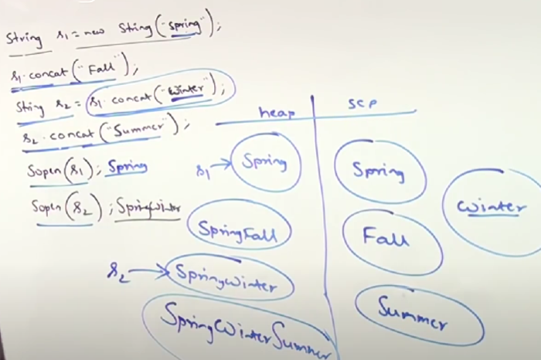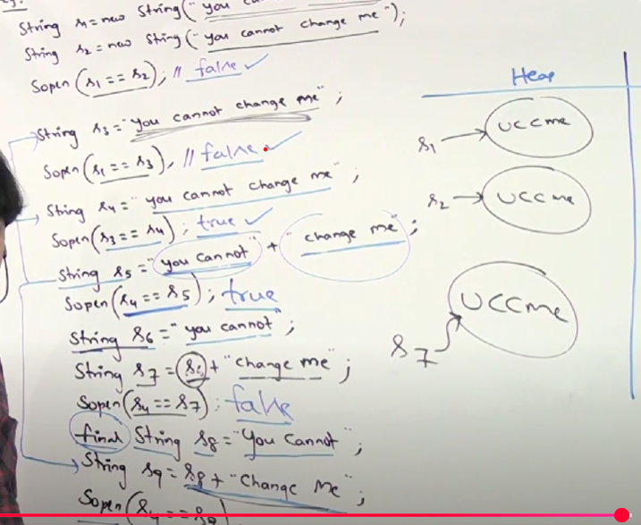

Note : - You Not Assign the reference they are eligible for garbage collection.

Your Assign the reference they are the store .

**Important Methods Of String Class :**

1. **isEmpty()** : If you create String object but you not mention any “” string then output will be false. isEmpty method check String available or not.

Eg . String s = new String(“ ”); sop(s.isEmpty); o/p – false

String s = new String(“Aniket”); sop(s.isEmpty()); o/p – true

1. **length()** : length method it is used to count the character of string and retrun o/p in number.**length()** applicable for **String** concept & **length** variable applicable for **arrays**

Eg. String s = new String(“Aniket”); sop(s.length()); o/p – 6

3.**replace()** : The replace() method is used replace old character with new character.

Eg. String s = new (“ababab”); sop(s.replace(‘a’, ’b’) ; o/p =bbbbbb

4.substring() : The substring() method returns begin index to end of the String. It is to be return substring.

Eg. String s = **new** String("Aniket"); sop(s.substring(2)); o/p= iket

4.**indexOf()** : The returns indexOf() specific character.This character represent yet which index.

Eg. String s = new String(“Aniket”) ; sop(s.indexOf(‘I’)) ; o/p = 2

**Reason** – The character is not available and u find index at which place so o/p is -1

Eg. String s = new String(“Aniket”) ; sop(s.indexOf(‘s’)) ; o/p = -1

**Reason** – The multiple character is available and u find the index at which place. The indexOf() find first character only.

Eg. String s = new String(“aaniket”) ; sop(s.indexOf(‘a’)) ; o/p = 0

**5.lastindexOf()** : The multiple character is available and u find the last index at which place.

Eg. String s = new String(“aaniket”) ; sop(s.lastindexOf(‘a’)) ; o/p = 1

**6.toLowerCase()** – toLowerCase() method convert capital letter to small letter.

Eg. String s = **new** String("ANIKET"); sop(s.toLowerCase()); o/p = aniket

**7.toUpperCase()** – toUpperCase() method convert small letter to upper letter.

Eg. String s = **new** String("aniket"); sop(s.toUpperCase()); o/p = ANIKET

8.**trim() :** Any blank spaces remove present at begin of string and end of string.

Eg. String s = **new** String(" Aniket Nangare "); sop(s.trim()); o/p = Aniket Nangare

And also not remove middle blank spaces.

**Q. Create own immutable class?**

* If you declare final keyword before class cannot be override.Because this is final class.

**Important Constructor Of String Class : -**

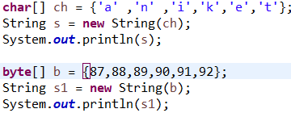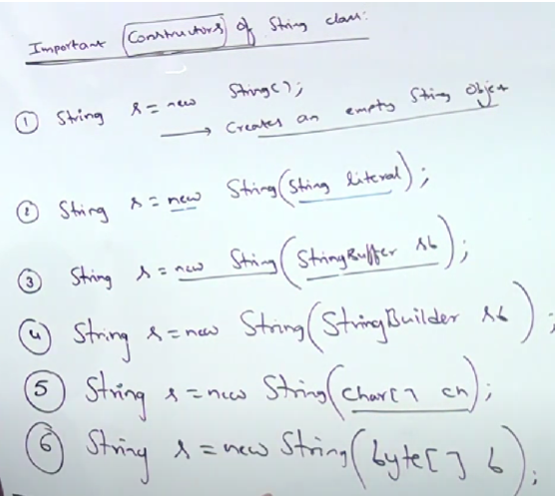

String Compare-

Object 🡪 Object equals() method is override for String Compare

Object.equals() -Compares 2 Objects of Object Class.

Ex-

String S = “Java”;

String S1= new String(“Java”);

String S2 = “Java”;

String S3 = “java”;

String S4 = new String(“Java”).intern();

**Three ways to compare- (Returns Boolean Values)**

1.equals(); – (It Checks Contents for comparison)

String.equals() -Compares 2 Objects of String Class.

Ex-

S.equals(S2); 🡪true

S.equals(S3); 🡪false

S1.equals(S2); 🡪true

.equalsIgnoreTo(); - (It Checks Contents ignores Case is upper or lower)

S.equalsIgnoreTo(S3); 🡪true

2.== Operator – (It Checks references/ addresses)

Ex.

(S == S1) 🡪false

(S == S2) 🡪true

(S1 == S3) 🡪false

(S == S4) 🡪true

**Interview Question :**

**1.Why SCP concat is available is only for String object but not available for StringBuffer?**

* String is most commonly used object in java. Java is provided specially memory management for the string
* StringBuffer is rarely used object specially memory management

**2.Why String objectis immutable and StringBuffer object is mutable?**

* SCP concept available for String object.
* For SCP Same object/reference can be reused to multiple times in String class
* In StringBuffer SCP concept not there . If reusing same object is SCP concept not there .
* Every time sperated object created.

**3.Inaddition to string object any other object are immutable in java?**

* Any other immutable in java is **Yes** all wrapper class object are also immutable
* Byte-short-Integer-long-float-double-character-boolean.
* **Q . Needs Of String Buffer?**
* If you create stringbuffer object & you change the existing contain then not creating new object internally.The biggest advantage of StringBuffer compare with String.

But String concept is you change the contain every time ,new object creating internally that why memory loss , low performance .

* **Important 3 Constructor Of String Buffer :**
* **First Constructor : -**
* Once creating empty stringbuffer object the by default internally capacity is 16 character.
* You can append the contain + 1 the latest capacity is 34.
* **Formula : current capacity + 1 * 2 = 34**

StringBuffer sb = new StringBuffer(“AAAAAAAAAAAAAAAA”) -🡪 16 CH

sb.append(“A”) +1 = 17 *2 = 34 (Now new capacity is 34. This is new object and previous object is going in garbage collection).

* **Second Constructor : -**
* StringBuffer sb = new StringBuffer (int intialCapacity);

StringBuffer sb = new StringBuffer (1000);

Sop(sb.capacity()); O/P = 1000

* **Third Constructor : -**
* StringBuffer sb = new StringBuffer (String s);

StringBuffer sb = new StringBuffer (“Aniket”);

Sb.length + 16 (6+16 = 22 capacity).

* **Methods Of StringBuffer : -**

1. **length() :** The method in StringBuffer class to get current character length.
2. **capacity() :** The method in StringBuffer class to get current capacity.
3. **charAt() :** The method returns the character at the specified index in the StringBuffer.
4. **setCharAt() :** Use of setCharAt replace the character you passed the index

**Example :** StringBuffer sb = new StringBuffer(“Aniket”);

sb.setCharAt(0,’a’); sop(sb) o/p = aniket

1. **append() :** The append() method modifies the existing StringBuffer and returns the updated StringBuffer.
2. **Inert() :** This method allows you to add characters or strings into an existing StringBuffer without replacing the current content.

**Example :** StringBuffer sb = new StringBuffer(“Aniket”);

sb.insert(1 , ‘a’); sop(sb) ; o/p = Aaniket

1. **delete() :** The delete() method You can specify a **start index** and an **end index**, and the method will remove all characters between those indices.

**Example :** StringBuffer sb = new StringBuffer(“Aaniket”);

sb.delete(1 , 3); sop(sb) ; o/p = Aket

1. **deleteCharAt()** : The deleteCharAt() method used to remove a single character at a specified index from the StringBuffer object.
2. **Reverse()**  : The reverse() method used to **reverse** the order of contain not a character in the StringBuffer object.
3. **setLength()** : The setLength() use to you need specified character and remaining character automatically removed

**Example** : StringBuffer sb = new StringBuffer(“Aniket Nangare”);

sb.setLength(5); sop(sb) ; o/p = Aniket

1. **ensureCapacity() :** If you want to increase capacity dynamically then you go requirement for ensureCapacity().
2. **trimToSize() :**  It reduces the internal storage of the StringBuffer to exactly fit the number of characters it currently holds, saving memory by removing any unused capacity.

**Example :**

StringBuffer sb = new StringBuffer();

sb.append("Hello, World!");

System.out.println("Capacity before trim: " + sb.capacity()); // Example output: 34 (default or auto-extended capacity)

sb.trimToSize(); // Trims the capacity to the length of the string

System.out.println("Capacity after trim: " + sb.capacity()); // Output will be 13 (the current length of "Hello, World!")

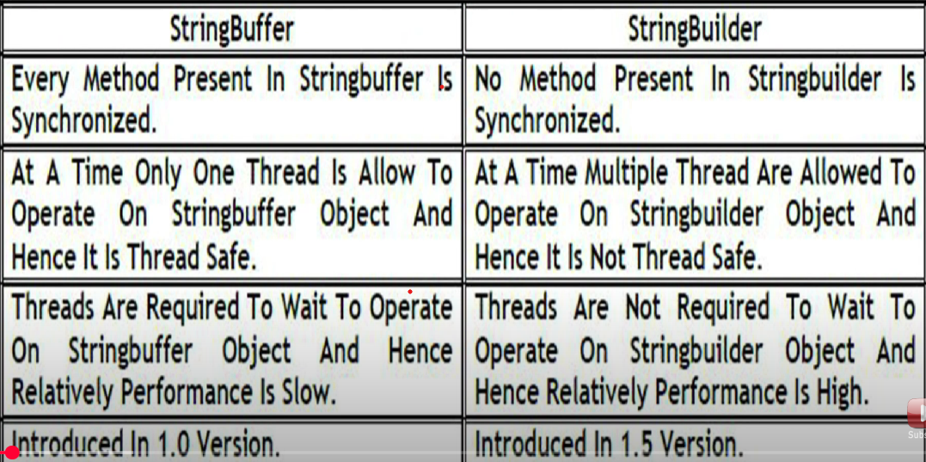

|  |  |  |
| --- | --- | --- |
| String | StringBuffer | StringBuilder |
| 1.Contain is fixed wont change frequently you recommended String. | 1.Contain is not fixed keep on changing but thread safety is required | 1. I don’t want thread safety multiple treads operate simultaneously |
| 2.String is thread safe because all immutable object is thread safe. | 2. SB is thread safety because one thread operate at a time. | 2.Sb is non thread safe because multiple thread operate at a time |

**Method Chaining :** - In Java, method chaining refers to calling multiple methods on the same object in a single line of code

StringBuilder sb = new StringBuilder();

sb.append("Aniket").append("Vasant").append("Nangare").reverse(); sop(sb);

* Exception handling- ( predefined package 🡪 java.lang)

What is Exception in Java-

It is an event that disrupts the normal flow of program. If Exception occurs in program then below line of code doesn’t execute.

What is Exception handling in Java-

It is a powerful mechanism that handles runtime exceptions. So the normal flow of the program can be maintained.

Hierarchy of java Exception-

* which are having able in last of the word the 99% of them are interfaces.
* But throwable is a Class.

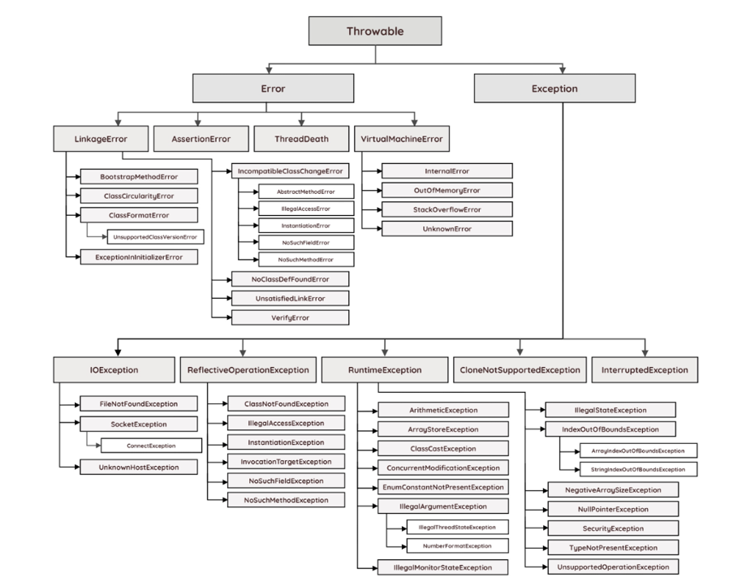

Ways to handle –

1.try catch block-

try{

This is the try block

In this block , keep those statement which may throw run time exception

}

Catch{

This is the catch block ,

It takes one argument of type java.lang.Exception

This block catches the exception thrown by try block

}

Nested Try catch block in Java:(Inner Try catch block)-

In java try catch blocks can be nested i.e one try block can contain another try-catch block.

Multiple catch block in java (till jdk 1.6)-

- In some cases, a single statement may throw more than one type of exception. In such cases, Java allows you to put more than one catch block. One catch block handles one type of exception.

- When an exception is thrown by the try block, all the catch blocks are examined in the order they appear and once catch block which matches with exception thrown will be executed.

- we can add multiple catch blocks only in sequence of parent-child relationship

|- catch(child/same level exception first ){ }

|- catch(child/same level/parent exception) { }

|- catch(exception) { } 🡪 (add parent exception last if we miss any exception in above code then it will detect on it)

Printing Exception message ways:

- *printStackTrace()* method : It prints the name of the exception, description and complete stack trace including the line where exception occurred .

- *getMessage()* method: Mostly used, It prints the description of the exception.

- *e.toString():* It prints name and description of the exception

Try catch using pipe (|) operator:

- From java 7 onwards, there is one way for handling multiple exceptions. Multiple exception thrown by the try block can be handled by a single catch block using pipe (|) operator.

- ex. ()

Catch() { } 🡪(parent child sequence)

2.finally block- (till jdk 1.6 after jdk 1.7 it was upgrades to resources (try-catch-resources))

try{

This is the try block

In this block , keep those statement which may throw run time exception

}

Catch{

This is the catch block ,

It takes one argument of type java.lang.Exception

This block catches the exception thrown by try block

}

finally{

this block is executes everytime.

to close inbuild classes like *Scanner* it was used.

it can be written directly after try block or after catch block.

}

Q. write the finally block but don’t execute that block?

-> using inbuild class - System.exit(0); (the program will be exited from that line)

3.throw

4.throws

Types of Java Exception-

1.Checked (Compile time)-

These exceptions are checked at compile time. If your code has a possibility of throwing a checked exception, you must either handle it using a try-catch block.

2.Unchecked (Runtime)-

These are exceptions that are not checked at compile time and can occur during runtime.

3.Error

* Serialization- (inbuild package🡪 java.io)
* Conversion of object into bytestream(byte code).
* Data security while transferring data between 2 applications (or in different machines).
* To persist(data needed for long time) that data in database.
* Deserialization- (java.io)
* Conversion of bytestream (txt file) in object.
* It is use to reconvert the file which is converted in serialization.

Throw:(User)- Java throw keyword is used to throw an exception explicitly.

We can throw either checked or unchecked exception

It’s mainly used to throw a custom exception

for example

throw new exception class (“error message”);

Throws: (developer)-

The java throws keyword is used to declare an exception. It gives an information to the programmer that there may occur an exception. So it is better for the programmer to provide the exception handling code so that the normal flow of the program can be maintained.

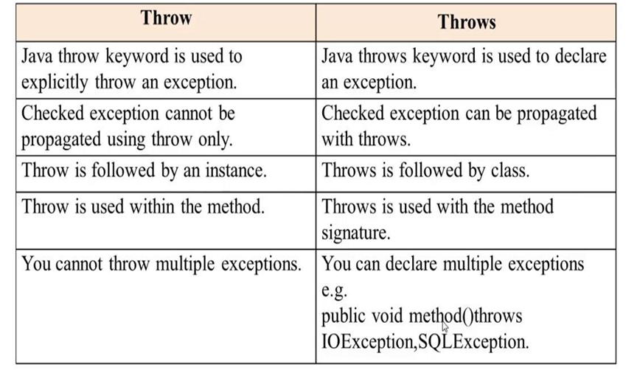

* Collection-

|  |  |
| --- | --- |
| Arrays | Collections |
| 1.Arrays are fixed sizd | 1.Collection is grow |
| 2.Memory POV array is not recommended | 2.Memory POV collections are recommended |
| 3.Performance wise array is good. | 3.Performance wise collection is not good. |
| 4.Arrays can hold only Homogenious data | 4.Collection can hold both Homogenious and hetrogenious data. |
| 5.Arrays can hold premitives & objects data type | 5.Collection can hold only objects (Wrapper classes for primitives). |

Collection-

- Collection is individual group of objects.

- Collection interface is consider as root interface of collection frameworks.

- In collection we can perform operation on data such as searching, sorting, insertion, manipulation & deletion.

- it represents single unit of object.

Common Methods of Collection Interface-

1. **add() : -** It is used to single object.
2. **addAll() :**- It is used to group of all collection object.
3. **remove() :-** It is used to remove particular object.
4. **removeAll():**- It is used to remove group of all collection.
5. **Clear():**- It is used to clear all object.
6. **retainAll():**- Accept the this collection of object & all remaining of object then remove.
7. **isEmpty():**- Whether my object available or not.
8. **size():**- I want to know size of object.
9. **contains():**- Can we check whether particular object available or not.
10. **contains():**- Can we check whether group of object available or not.
11. **c.toarray():-** If I convert collection to array. And this method return type of Object[] a = c.toArrray();
12. **iterator():**- I want to get object one by one. And this method return type is Iterator = iterator();

Framework-

- It provides readymade architecture.

- It represents a set of classes and interfaces.

- It is optional.

Collection Framework- (inbuild package 🡪 java.util) (jdk 1.2)

- it is a centralized and unified theme to store and manipulate the group of objects.

- it provides some pre-defined classes and interfaces to handle the group of objects.

- you can store the objects as a **list** or as a **set** or as a **queue** or as a **map** and perform operations like adding an object or removing an object or sorting the objects without much hard work.

- supports homogeneous data

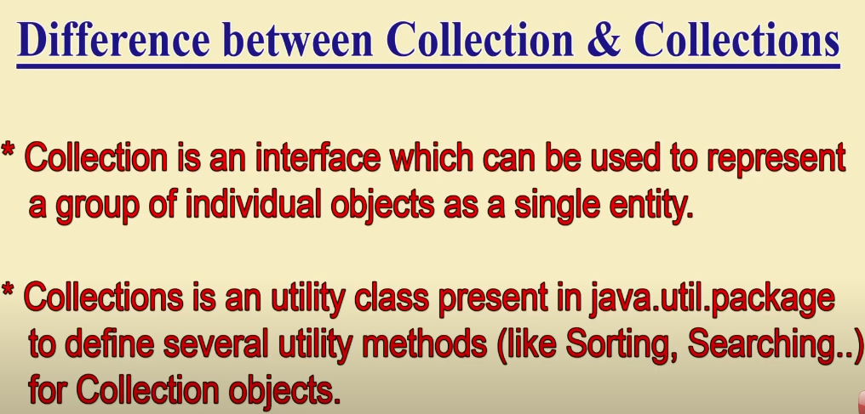

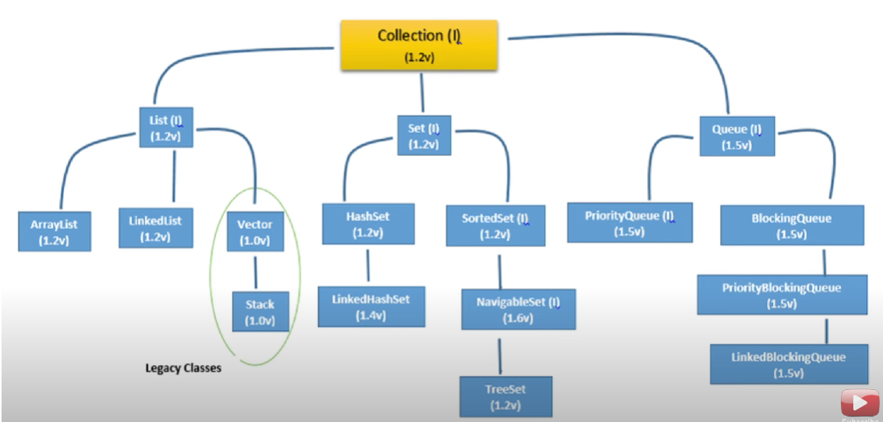

**1. List Interface- (package- java.util)**

- List interface represent an ordered or sequential collection of objects.

- This interface has some methods which can be used to store and manipulate the ordered collection of objects.

- The classes which implemented the list interfaces are called as Lists.

- Arraylist, linkedlist , vector are some examples of list interface .

**List Properties-**

**- index player is most important in list interface.**

- follows insertion order. **(How :- based on index)**

- maintain indexing.

- Duplicate element are allowed. **(How :- elements are duplicate but index is different that’s why duplicate element are allowed in list ).**

- random access to any element.

- We can store multiple null element.

* **Method of List Interface : -**

1. **indexOf() :-** It is used to check at which index a specific object is located.
2. **lastIndexOf:-** Duplicate element are available in list but check first element at which index then you should go for indexOf() but I want to second element at which index then you should go for lastIndexOf(). Method.
3. **get():-** Using the get() method to retrieve an element.
4. **set():**- The set() method **replaces** the element at the specified index with the new element.

Generic-

<String> 🡪 generic can add primitive datatypes & only custom classes can be added .

* Collection framework is non generic before jdk 1.5 since 1.5 it is generic.
* Allows only 1 type of object.
* It is type-safe so type-casting is not required at runtime.

1. **ArrayList Class- (package java.util)**

* Resizeble array or growable array.
* Duplicate are allowed bcz List interface child of ArrayList class.
* Insertion order follow.
* Null Insertion allowed.
* Support Hertrogeneous (means different types of data type).
* When an ArrayList is created, its default capacity or size is 10 if not provided by the user.
* The size of the ArrayList grows based on load factor and current capacity.
* The Load Factor is a measure to decide when to increase its capacity.
* The default value of load factor of an ArrayList is 0.75f

ArrayList in Java expands its capacity after each threshold which is calculated as the product of *current capacity* and *load factor* of the ArrayList instance.

Threshold = (Load Factor) * (Current Capacity),

For example, if the user creates an ArrayList of size 10,

Threshold = Load Factor * Current Capacity

= 0.75 * 10

≅ 7

This means after adding the 7th element to the list, the size will increase as it has reached the threshold value. Internally,

a new ArrayList with a new capacity is created and the elements present in the old ArrayList are copied in the new ArrayList.

declaration,

List<E> al = new ArrayList<E>(); 🡪(loose coupling)

al.add(null);

ArrayList<E> als = new ArrayList<E>(); 🡪(tight coupling)

Als.add();

* **Three constructor of ArrayList() :-**

**1.**ArrayList list = new ArrayList(); **(create Default arraylist & default capacity is 10)**

2.ArrayList list = new ArralyList(int intialCapacity);

**(This constructor used for huge capacity mention it. Therefore performance is fast.)**

3.ArrayList list = new ArrayList(Collection c);

* Usually we can use Collections to hold and transfer Objects from one place to another place, to provide support for this requirement every Collection already implements Serializable and Cloneable interfaces.
* **How to get synchronized version of ArrayList Object?**
* By default ArrayList is non synchronized but we can get synchronized version of ArrayList by using Collections Class synchronized() method.
* Public static List synchronizedList(List list)

ArrayList al = new ArrayList();

List list = Collections.synchronizedList(al);

1. **LinkedList class – (package- java.util)**

* It is represent frequently insertion & deletion operation in middle we recommended go for LinkedLIst.
* It is worst choice for retrieval operation using LinkedList

(**Note:-** I want to get element on 5th index because in retrieval operation starting from 0 index to 5 index (wait 5sec).

**The important points about Java LinkedList are:**

* Duplicate elements are allowed.
* Follow insertion order.
* Heterogeneous are allowed.
* non synchronized.
* Multiple null element allowed.
* Underline data structure is doubly linkedlist.
* Linkedlist is serializable and cloneable interface but not random access.
* LinkedList base implementation Stack (LIFO)& Queue.(FIFO)
* **Methods Of LinkedLIst :-**

This methods only can apply linkedList class.

1. **Void addFirst() :-**
2. **Void addLast():**
3. **Object getFirst():**
4. **Object getLast():**
5. **Object removeFirst():**
6. **Object removeLast():**

* **Constructor Of LinkedList:-**

1. LinkedList list = new LinkedList();

**(Create default linkedlist constructor & no default capacity for linkedlist)**

1. LinkedList list = new LinkedList(Collection c);

**(We can convert any collection object into LinkedLIst)**

* **Difference Between ArrayList and LinkedList :**

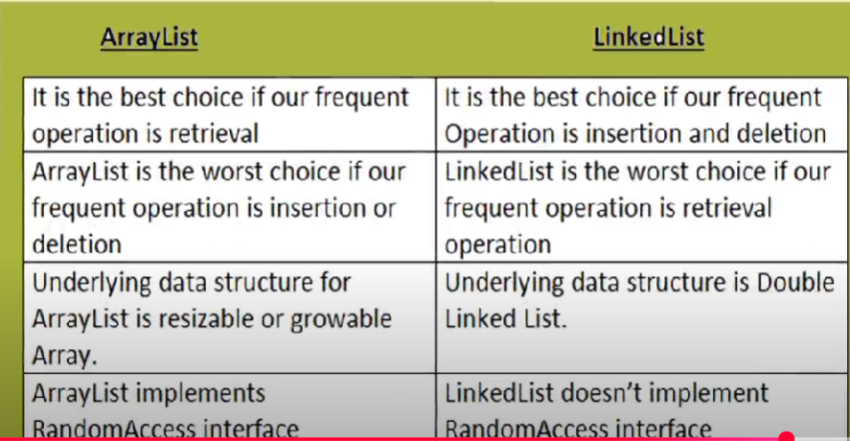

|  |  |
| --- | --- |
| ArrayList | Vector |
| 1.ArrayList is Non-Synchronized(multiple thread operation) | 1. Vector is Synchronized(single thread operation). |
| 2.ArrayList is non thread safe. | 2.Vector is thread safe |
| 3.Performance is high(because all threads operation simultaneously.) | 3.Performance is low(because single thread operation at a time remaining threads waiting for first thread completing |
| 4.ArrayLIst version 1.2v it is not legacy. | 4.Vector version1.0v it is legacy. |

**3.Vector :-**

* Vector is resizable array / growable array.
* Duplicate are allowed.
* Insertion order is preserved.
* Null insertion is allowed.
* Hertogeneous object is allowed.
* Vector is always implements of serializable and cloneable interface.
* Random access interface(means fetching operation).
* Vector is best choice for retrieval (fetch) operation.
* **Constructor of Vector:-**

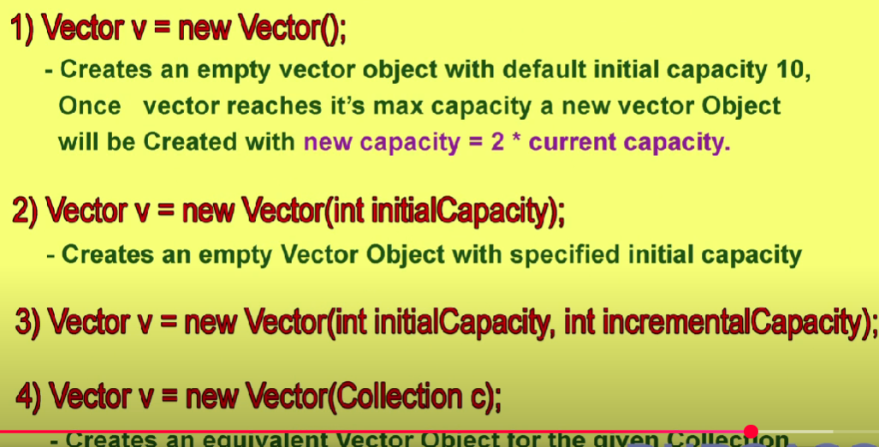

1. **Stack class:-**

* Stack class child of vector interface.
* Stack class specially design for LIFO.
* **Constructor of Stack Class:-**
* Stack s = new Stack();
* **Methods Of Stack Class : -**

1. **push(Object o) :-** It is used to insert the data to the stack.
2. **pop(Object 0 ) :-** It is used to return and remove top of stack.
3. **peak(Object o) :-** It is used to return top of stack without removeal.
4. **empty() :-** It is used to check element or not.
5. **search():-**  It is used to you want to search specific element. It element is available then return offset & no element in database and you search it then return is -1.

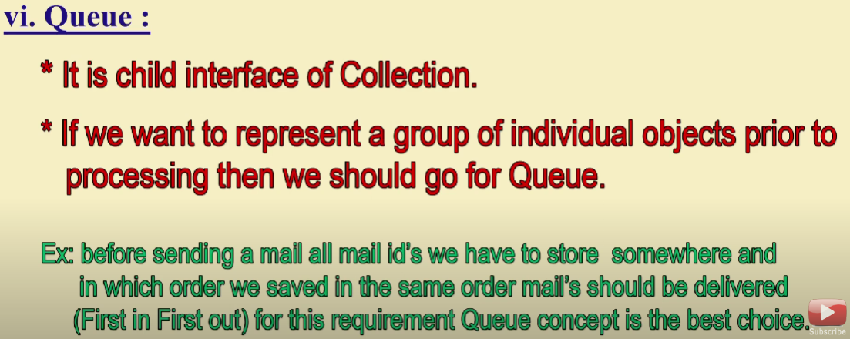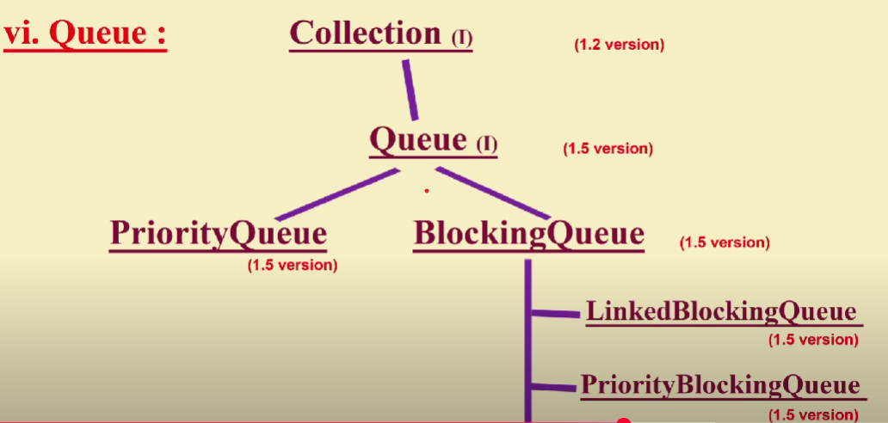

|  |  |
| --- | --- |
| **List** | **Set** |
| 1.Follow Insertion order | 1.. Insertion order not preserve |
| 2.Duplicate order not allowed | 2.Duplicate order allowed |

**2. Queue (I) :**

* Before processing if you want to represent group of object is a single entity then you go for queue interface.

1. **PriorityQueue(C) :**
2. **BlockingQueue(C) :**

* **Priority Queue:**
* **LinkedBlockingQueue :**

**3. Set (I) :**

* Set is child interface of collection.
* If you want to represent a group of individual object
* Duplicates are not allowed.
* Insertion order not follow.
* Set interface doesn’t contain any new methods. So we have to use only collection interface methods.

**Properties of Set:**

* set contain only unique elements. It does not allow duplicate.
* Set can contain only one null element.
* Random access of elements is not possible.

1. **HashSet- (package- java.util)**

* The underline data structure for hashSet is hashtable.
* Duplicates are not allowed.**(If you trying to add duplicate value no compile time error & no run time exception because simply returns false.**

**eg.** 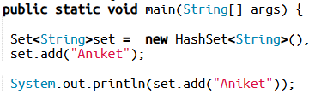

* Insertion order not follow. All object inserted based on hashcode.
* Heterogeneous object is allowed.
* Implements serializable and cloneable interface.
* No Random Access.
* HashSet is best choice ,If our frequent operation is **search** operation.
* Allows null values (only one null is allowed).
  + HashSet stores the elements by using a mechanism called hashing.
  + HashSet class is non synchronized.
  + The initial default capacity of HashSet is 16, and the load factor is 0.75

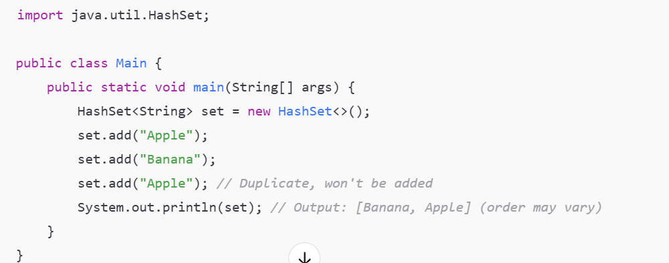

* **HashSet Related Constructor:-**
  + 1. **HashSet h = new HashSet() :-**
* If you create empty HashSet Object the default capacity is 16.& load Factor is 0.75.
* In HashSet fill the 0.75 after that new HashSet object is created
  + 1. **HashSet h = new HashSet(int initialCapacity):-**
* We can set customized initial capacity.
  + 1. **HashSet h = new HashSet(int initialCapacity, float loadfactor):-**
* We can set customized intial capacity with load factor.
  + 1. **HashSet h = new HashSet(Collection c) :-**
* For inter conversion between collection object.

1. **LinkedHashSet Class- (package- java.util)**

* Java LinkedHashSet class contains unique elements only like HashSet.
* Java LinkedHashSet class provides all optional set operations and permits null elements.
* Java LinkedHashSet class is non-synchronized.
* Java LinkedHashSet class maintains insertion order.
* LinkedHashSet is a child class of HashSet.

|  |  |
| --- | --- |
| **HashSet** | **LinkedHashSet** |
| 1.Insertion order not preserved | 1.Insertion order is preserved. |
| 2.The underline data Structure is hashtable | 2. The underline data Structure is hashtable + linkedList |
| 3. 1.2 version | 3. 1.4 version |

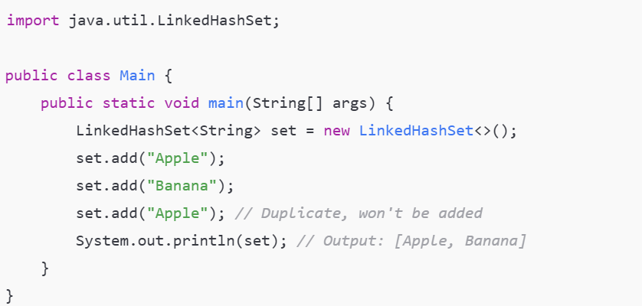

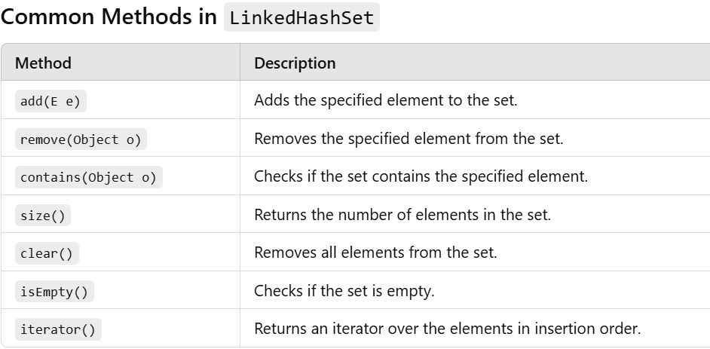

* **SortedSet(I) :**
* All Object inserted according to insertion order then you go for sortedset interface.
* **SortedSet interface** is a child of **Set Interface.**
* I want to represent group of individual object without duplicate but some sorting order is required.
* Duplicate element are not allowed.
* **Eg :- We can store all student object according to roll no**
* **Methods of SortedSet (I):-**

1. **first():-** Returns the first (lowest) element in the sorted set.
2. **last():-** Returns the last (highest) element in the sorted set.
3. **headSet(object o):-** Returns a view of the portion of the set whose elements are less than the specified element.
4. **tailSet(Object o):-** Returns a view of the portion of the set whose elements are greater than or equal to the specified element.
5. **subSet():-** Returns a view of the portion of the set whose elements are between the two specified elements.
6. **Comparator():**- comparator object which is describe underline sorting technique.

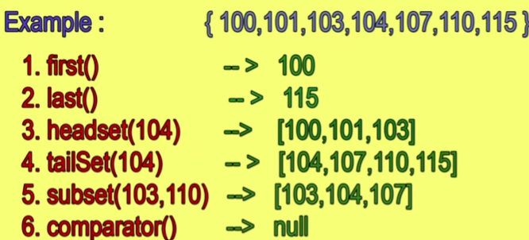

* **NavigableSet(I) :**
* TreeSet class is implemented of NavigableSet interface.
* **NavigableSet** is child of **Set Interface.**

1. **Tree Set (c)**

It implements the NavigableSet interface and extends the AbstractSet class. It is a part of the Java Collections Framework and is used to store elements in a sorted and unique order. Internally, it uses a TreeMap (a Red-Black tree) to manage the elements.

**The important points about the Java TreeSet class are:**

* Duplicates are not allowed.
* Insertion order not preserved.But all element insertion according to sorting order.
* Heterogeneous object is not allowed in tree set.(If you trying to insert heterogeneous object immediately going runtime exception (class cast exception)).
* Only once null element allowed in tree set.

(For empty treeset as the first element null insertion is possible. But after inserting that null if we are trying to insert any another element we will get NullPointerExcep.

* **What is underline data structure is a tree?**
* Balanced Tree
* **Constructor of Tree Set :-**

1. **TreeSet ts = new TreeSet();**

(If you create empty treeset object when elements will be inserted according to default natural sorting order(means ascending order) ).

1. **TreeSet ts = new TreeSet(Comparator c);**

(If you create treeset object but I want to customized sorting order like salary,id etc. then you should go for this object.

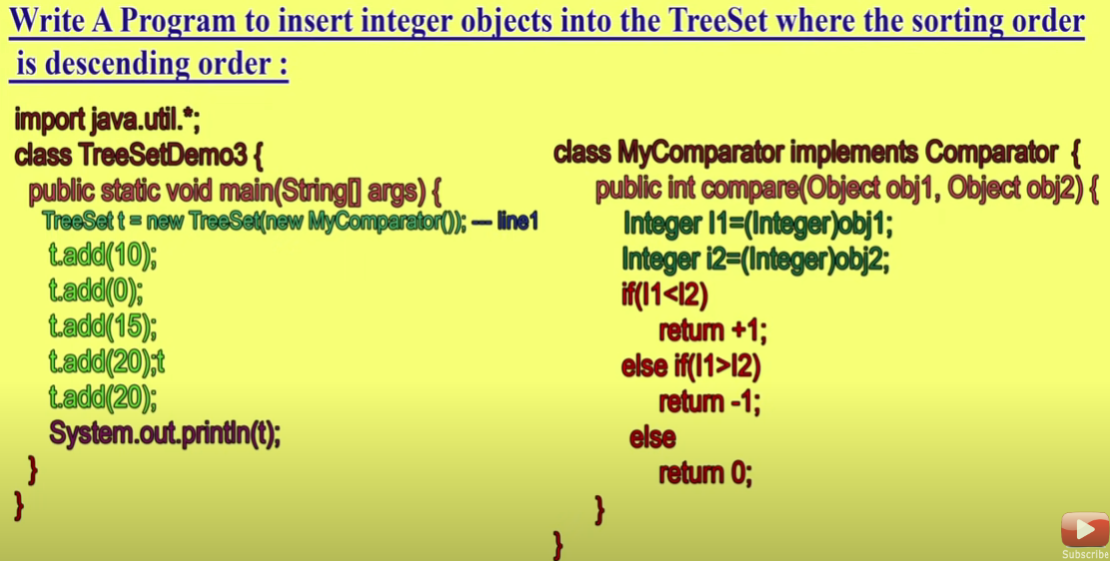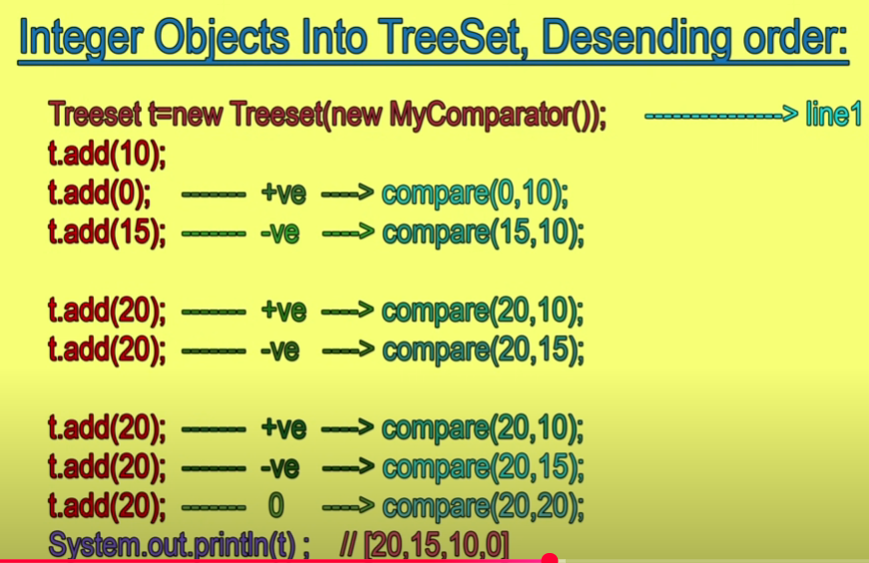

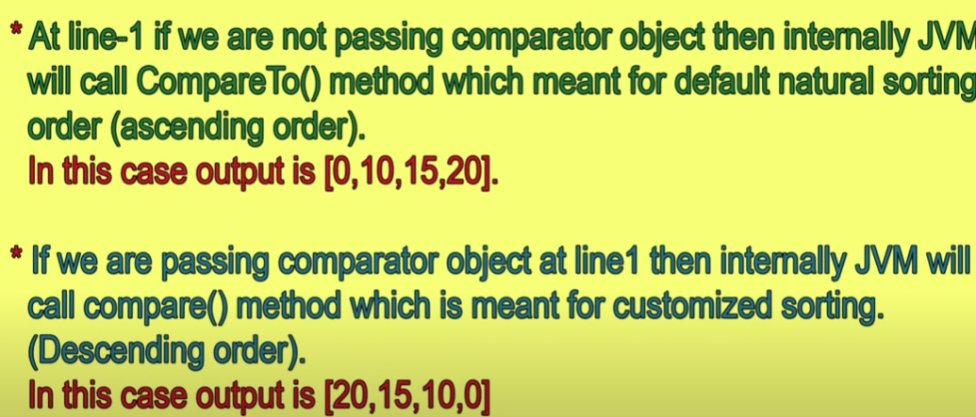

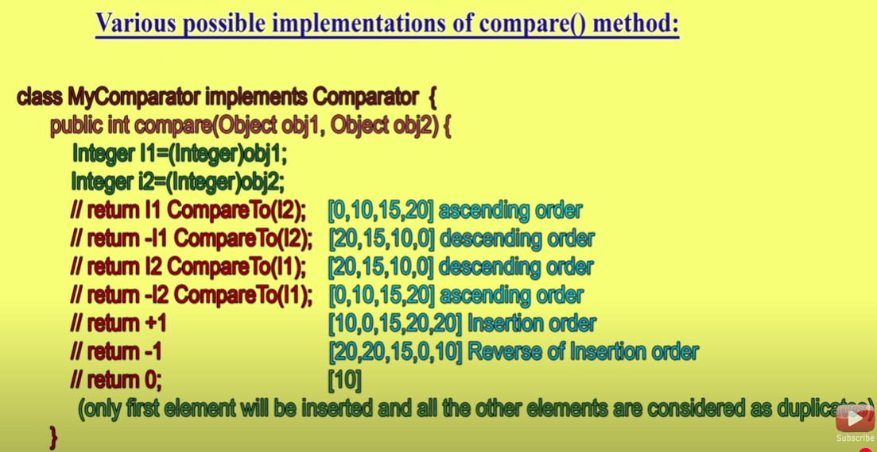

1. **TreeSet ts = new TreeSet(Collection c );**

(If you create treeset object you can pass any collection equivalent object)

1. **TreeSet ts = new TreeSet(Sortedset s);**

(If you give sorted set object we can create equivalent object).

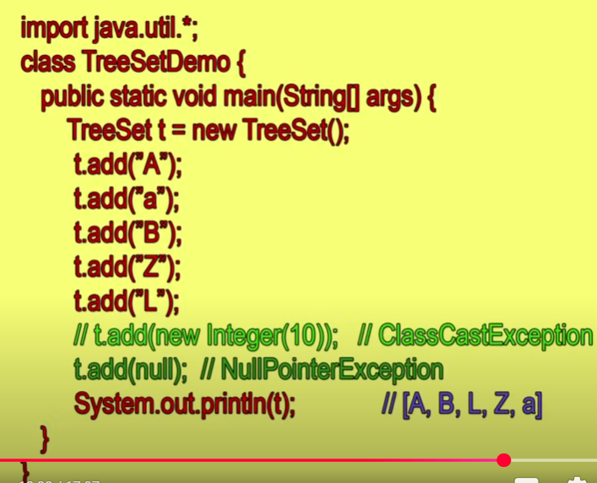

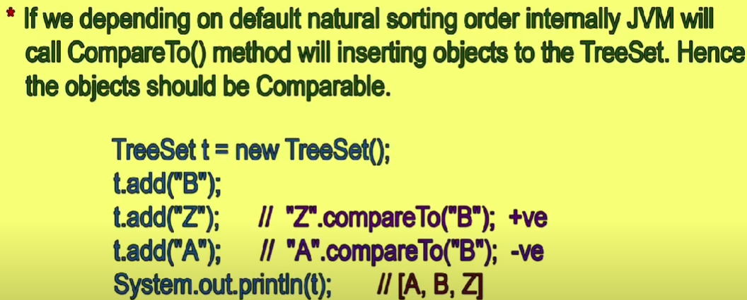

* **Eg.**

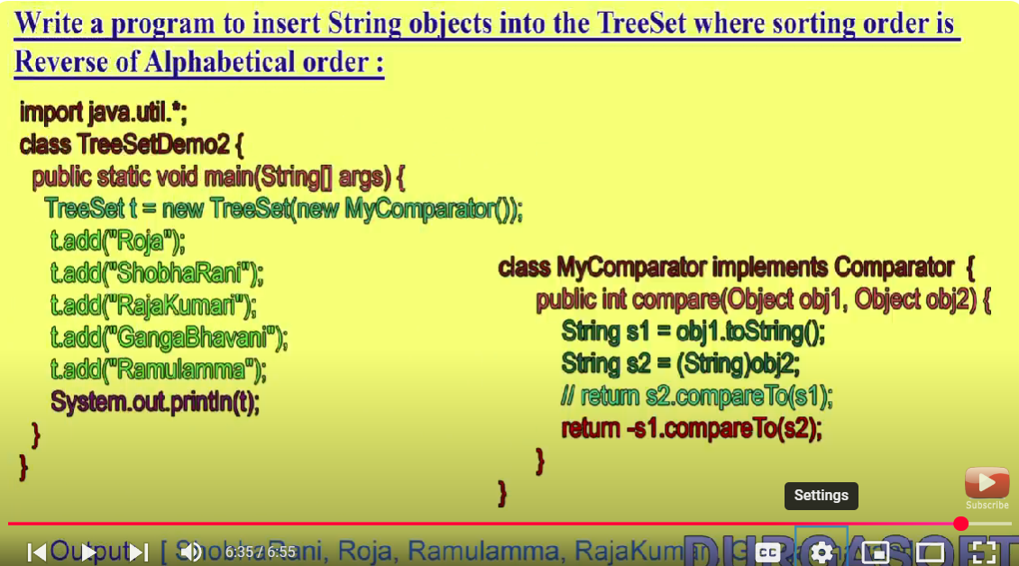

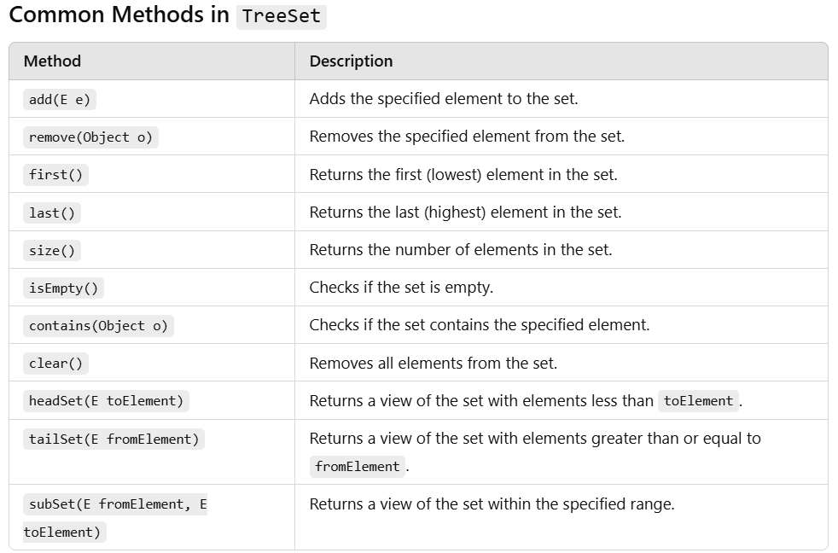

* **Cursor :**
* I want to get object one by one then you go for cursor
* Enumeration Interface
* Iterator Interface
* List Iterator Interface

**1.Enumeration :-**

* If you want to retrieve object one by one from the old collection object then we should go for Enumeration.
* How to get enumeration object:-

Enumeration en = v.element(); (v means vector object)

* We can perform only read operation in enu
* Two method apply on enumeration:-
  + 1. **public boolean hasMoreElements();** :- It is used to check more element or not.
    2. **public object nextElement();** :- If a more element are there can we provide nextElement

These are the two method available are in the Vector.

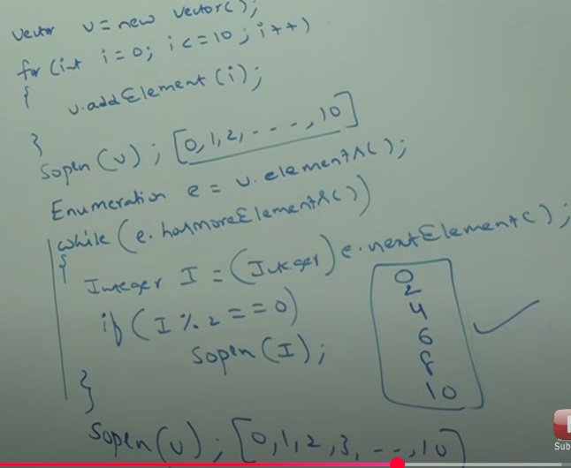

**2. Iterator- (package – java.util)**

* Iterator is universal cursor.
* **Advantage of Iterator It is applicable for any collection of class.**

**(compare to ListIterator)**

* **Disadvantage** We can perform both read & remove operation using iterator.**(Compare to ListIterator).**

**Key Features of an Iterator**

1. By using Iterator we can move only forword direction we can’t move backword direction
2. No Index Access: Unlike loops with indices, iterators don't use indices to access elements.
3. Fail-Fast: Iterators throw a ConcurrentModificationException if the collection is modified during iteration.

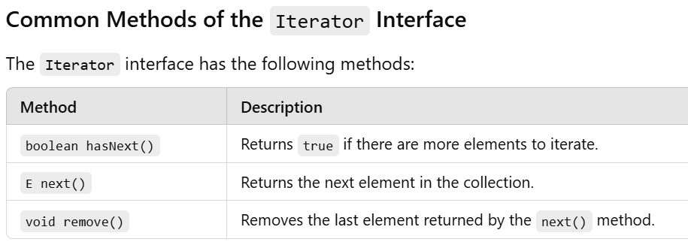

*Syntax-*

*// Get an iterator*

*Iterator<String> iterator = list.iterator();*

*// Iterate through the collection*

*while (iterator.hasNext()) {*

*String fruit = iterator.next();*

*System.out.println(fruit);*

*}*

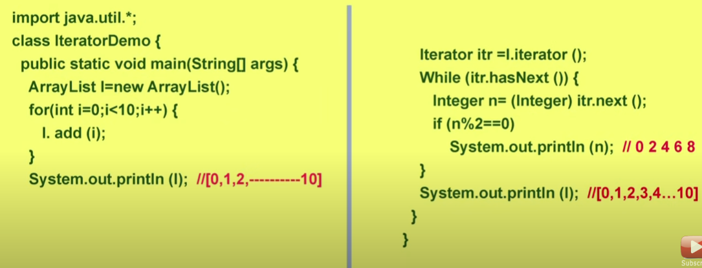

**3.ListIterator- (package -> java.util)**

* ListIterator we can move both direction forword & backword.
* ListIterator is by direction cursor.
* **Advantage** By using ListIterator we can perform read,remove,replacement,addition of new object.**(Compare to Iterator).**
* ListIterator is child interface of Iterator.(By default Iterator method automatically come Listiterator)
* **Disadvantage of ListIterator only applicable for List Interface (e.g., ArrayList, LinkedList).(compare to Iterator)**
* **Methods of ListIterator:-**
* **Forword Direction Methods:-**

1. **public boolean hasNext():-** If there check element are not then return is true.
2. **public object next():-** If there next element.
3. **public int nextIndex():-** It is next element is there then what is the index.

* **Backword Direction Methods:-**

1. **public boolean hasPrevious():-** If there check previous element are not then returns is true.
2. **public object previous():-** If there previous element what is the previous element.
3. **Public int previousIndex():-** If the previous element is there what is the index of previous element.

* **Others Methods :-**

1. **public void remove():-** It is used to remove the object.
2. **pubic void set(Object new):-** It is used to replace current object to new object.
3. **public void add(Object new):-** It is used to add new object.

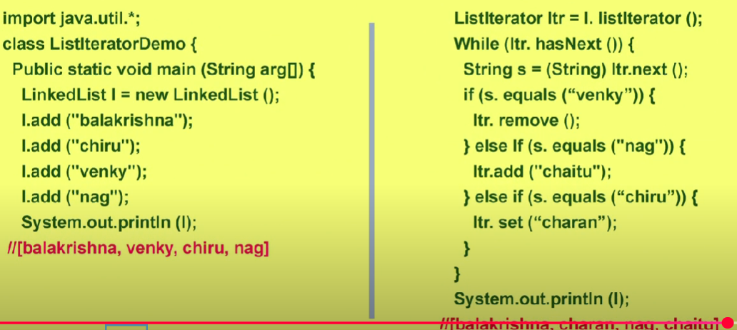

*Syntax-*

*// Get a ListIterator*

*ListIterator<String> iterator = list.listIterator();*

*// Forward traversal System.out.println("Forward Traversal:");*

*while (iterator.hasNext()) { System.out.println(iterator.next()); }*

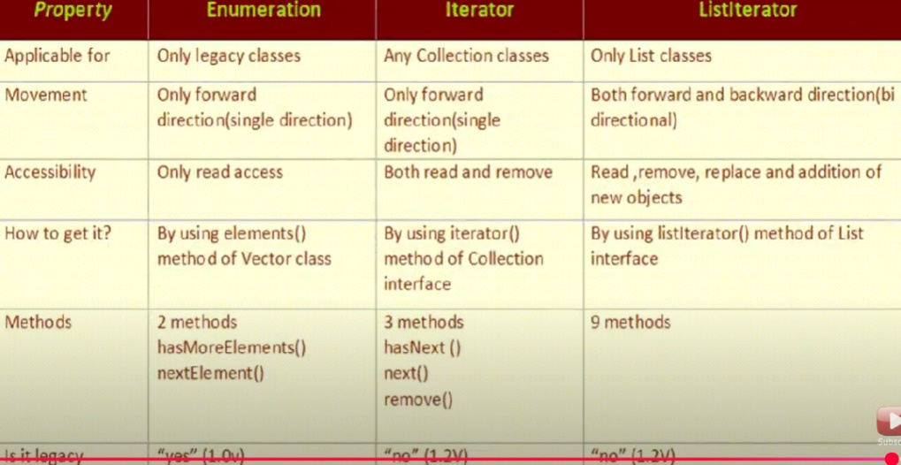

* Fail-Fast –

ConcurrentModifyException occurs if we try to manipulate data (add,remove,update) at the time of iteration.

Key Features of Fail-Fast Iterators:

1. Immediate Error: They detect structural modifications during iteration and fail fast by throwing a ConcurrentModificationException.
2. Structural Modification: This refers to operations that add, remove, or rearrange elements in the collection (e.g., add(), remove()).
3. Iterator Scope: Fail-fast behavior applies to iterators and enhanced for-loops, as they use iterators internally.
4. Non-Synchronized: Fail-fast iterators are not thread-safe; concurrent modifications in multiple threads can result in exceptions or unpredictable behavior.

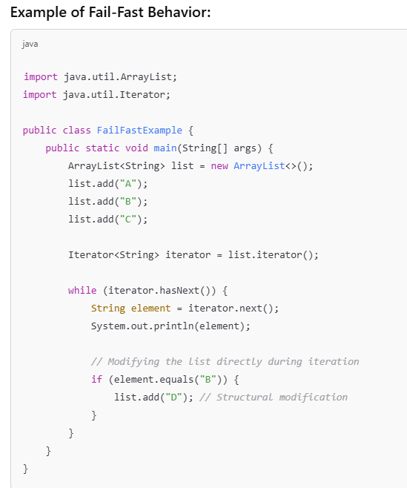

Collections with Fail-Fast Behavior-

Fail-fast iterators are typically used in non-thread-safe collections like:

* ArrayList
* LinkedList
* HashSet
* TreeSet
* HashMap
* TreeMap
* Fail-Safe in java-

fail-safe refers to a property of certain iterators that allow modifications to the collection during iteration without throwing a ConcurrentModificationException. These iterators operate on a separate copy of the collection (a snapshot), which ensures that structural changes do not affect the iteration process.

Key Features of Fail-Safe Iterators:

1. Snapshot-Based: Fail-safe iterators work on a clone or snapshot of the original collection, meaning they are unaffected by structural modifications.
2. Thread-Safe: These iterators are often used in concurrent environments where multiple threads might modify the collection simultaneously.
3. No ConcurrentModificationException: Modifications to the collection during iteration do not throw exceptions.

Examples of Fail-Safe Collections:

Fail-safe behavior is implemented in concurrent collections like:

* CopyOnWriteArrayList
* CopyOnWriteArraySet
* ConcurrentHashMap
* ConcurrentSkipListMap

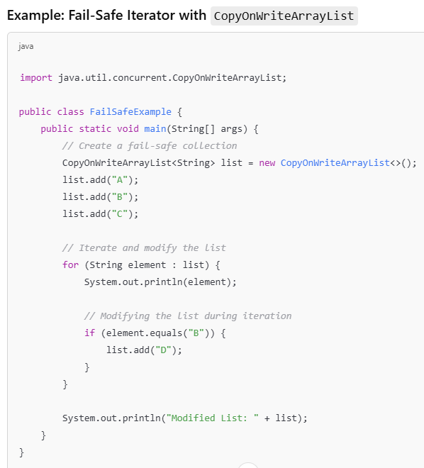

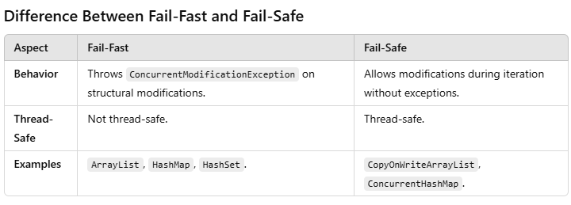

* **Comparable(I):-**
* **Comparable ment for default sorting natural order.**
* **compareTo() method available in Comparable(I).**

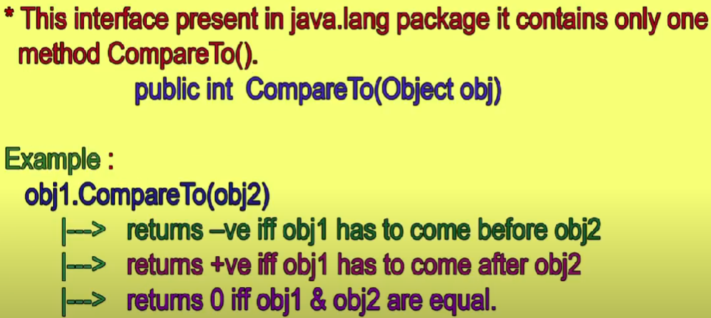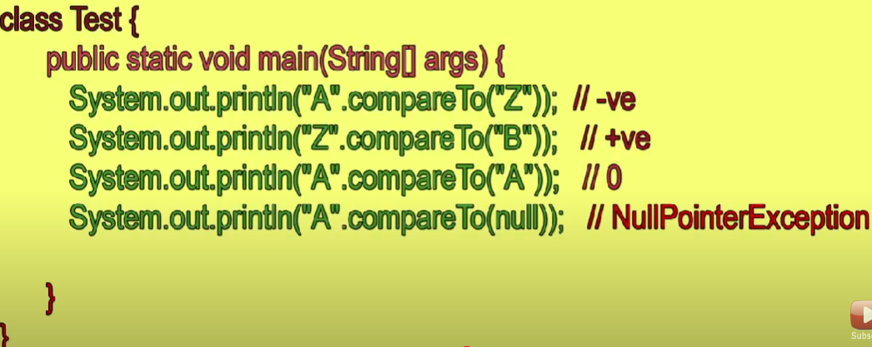

* **Comparator(I):-**
* **Comparator ment for customized sorting order**
* **compare() & equals() method available in Comparator()**

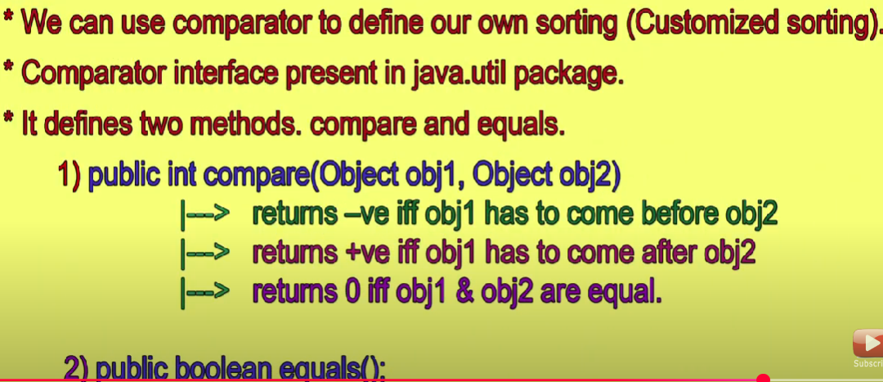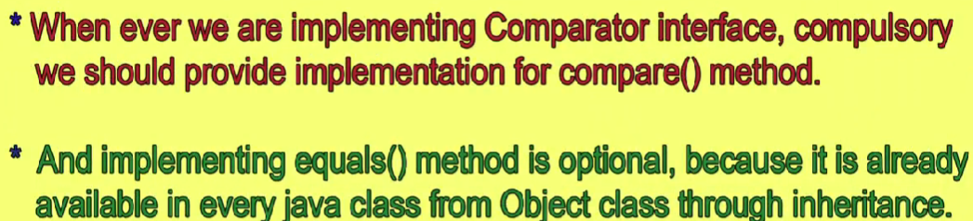

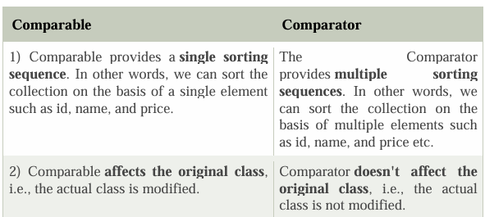

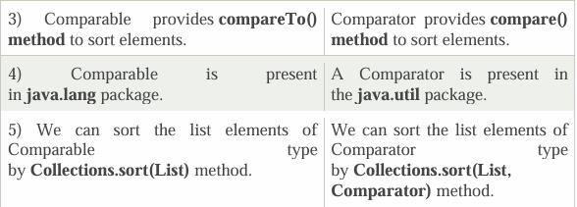

1. **Maps (I) :**

* A Map doesn't allow duplicate keys, but you can have duplicate values.
* Map is not child interface of collection.(map is difference & collection is difference)
* If you want to represent group of object is key value pairs.

(eg – 101 – Aniket / 102 – rohan/103- yash) no-key/ name – values.

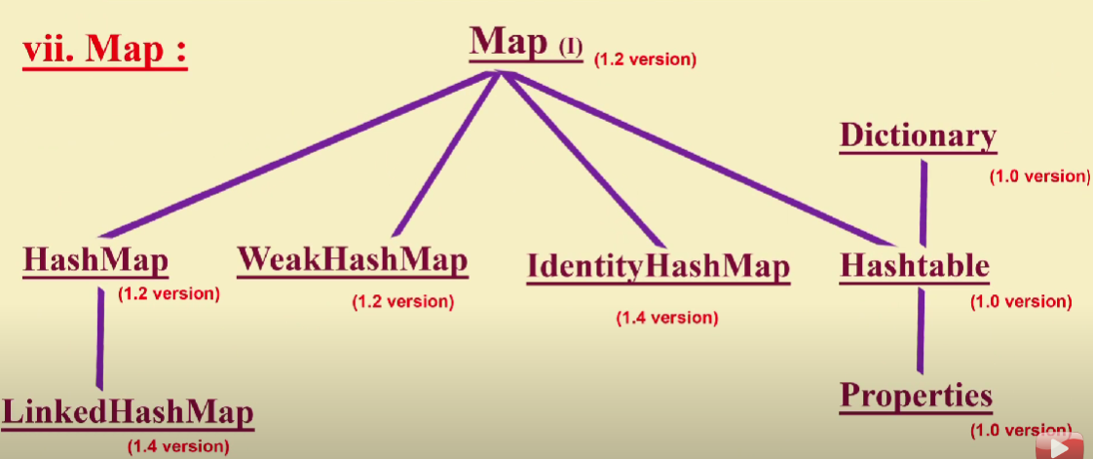

I. HashMap- (package 🡪java.util)

Java HashMap class implements the Map interface which allows us to store key and value pair, where keys should be unique. If you try to insert the duplicate key, it will replace the element of the corresponding key. It is easy to perform operations using the key index like updation, deletion, etc.

- It inherits the AbstractMap class and implements the Map interface.

Points to remember -

o It contains values based on the key.

o It contains only unique keys.

o It may have one null key and multiple null values.

o It is non synchronized.

o It maintains no order.

o The initial default capacity of Java HashMap class is 16 with a load factor of 0.75.

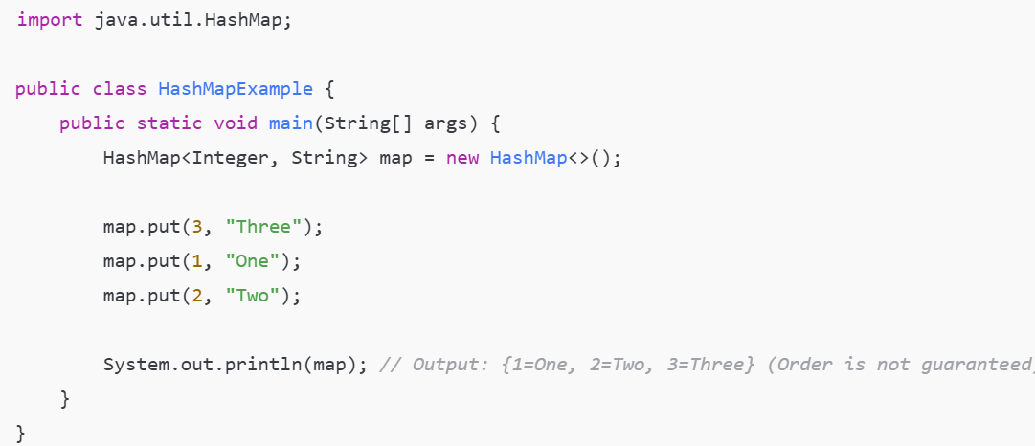

II. LinkedHashMap- ()

Java LinkedHashMap class is Hashtable and Linked list implementation of the Map interface, with predictable iteration order. It inherits HashMap class and implements the Map interface.

Points to remember-

o Java LinkedHashMap contains values based on the key.

o Java LinkedHashMap contains unique elements.

o Java LinkedHashMap may have one null key and multiple null values. o Java LinkedHashMap is non synchronized.

o Java LinkedHashMap maintains insertion order.

o The initial default capacity of Java HashMap class is 16 with a load factor of 0.75.

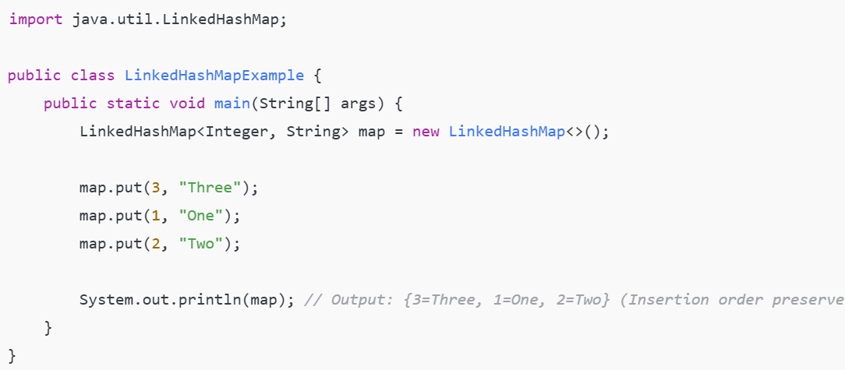

III. TreeMap- ()

Java TreeMap class is a red-black tree based implementation. It provides an efficient means of storing key-value pairs in sorted order.

The important points about Java TreeMap class are-

o It contains values based on the key. It implements the NavigableMap interface and extends AbstractMap class.

o It contains only unique elements.

o It cannot have a null key but can have multiple null values.

o It is non synchronized.

o It maintains ascending order.

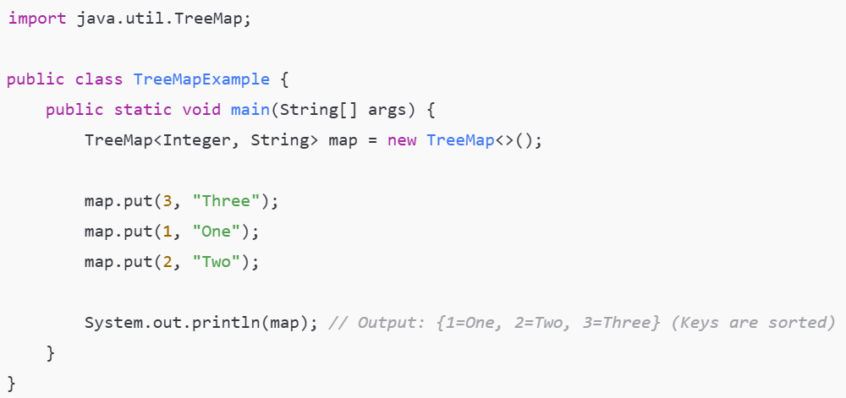

--------------------------------------------

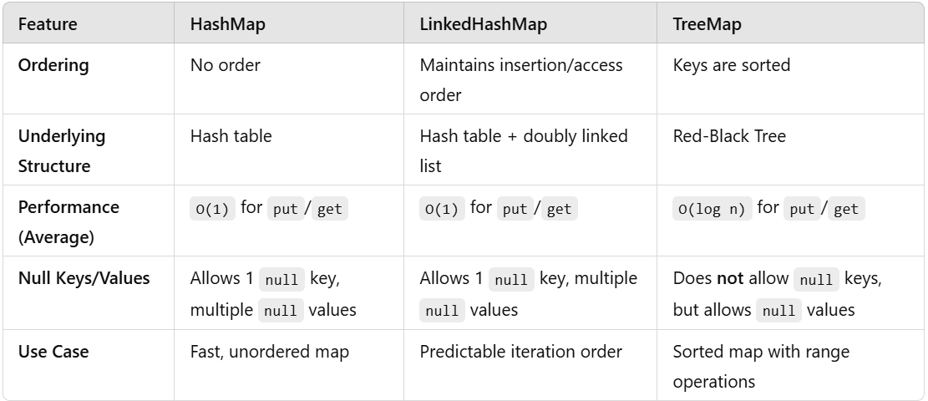

* Internal Working of HashMap-

Basics of HashMap

* Key-Value Pair Storage: Each entry in a HashMap is a key-value pair. Keys are unique, but values can be duplicated.
* Underlying Data Structure: HashMap uses a combination of an array and linked list (or a binary tree in some cases) to store entries.
* Hash Function: A hash function is used to calculate the index of the key-value pair in the internal array.

Buckets-

* the storing data in index that index is nothing but array bucket.
* In bucket data is stored in linkedlist.
* Since Java 8, when the size of a linked list at a bucket exceeds a threshold (8 by default), the list is converted into a binary search tree/ balance tree to improve search performance

Steps in HashMap Operations

1. Insertion (put() method)

* Step 1: Compute the hash code of the key.

Whenever put() method added it generates the hashcode

* Step 2: Calculate the index of the bucket using the hash function.

Formula - index = hash(key) % (16-1) 🡪(it will gave index to store that key & values)

* Step 3: Check the bucket at the calculated index:
  + If the bucket is empty: Create a new Node and store the key-value pair.
  + If the bucket is not empty:
    - Traverse the linked list (or tree) at the bucket.
    - Hash Collison occurs If the key already exists it checks by using .equals method that value is same or not if same then override the new value.
    - If the key does not exist, append the new Node to the list.

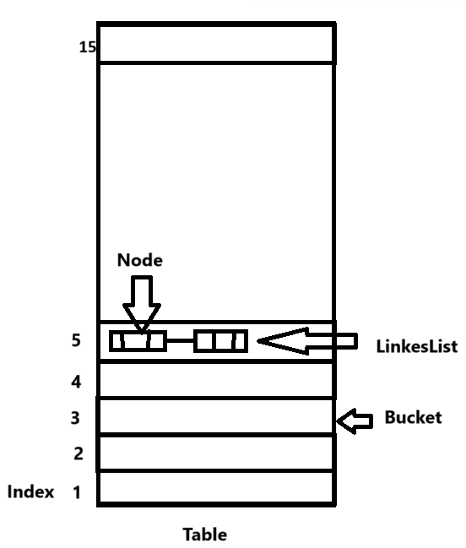

* Here is some question-

SOP(map.put(101,”java”)); 🡪 null

SOP(map.put(101,”CPP”)); 🡪 java

SOP(map.put(102,”Python”)); 🡪 null

* Because put method return type is value
* At the time of putting values in sop if there is no content at that index then its previous value is null so it will print null.
* & if there is same key present & in sop we are putting new value with same key then it will print previous value.

1. How it knows the values are null or not

Set.add(11);

Set.add(12);

Checks with –

Returns Boolean type - method

map.put(11, PRESENT) == null

null = null 🡪(true)

or

11=null 🡪 (false)

* true 🡪 then that index is empty & it will insert that value on that index
* false 🡪 then that index is contains any value & it will override with new value
* **SortedMap (1.2v):**
* I want to represent a group of object as key value pair according to some sorting orders of keys. Then you should go for sorted map
* Sorted Map is child interface of map
* **NavigableMap** **(1.6v):**:
* NavigableMap is child interface of SortedMap.
* **TreeMap(1.2v)** is class implementation of NavigableMap
* NavigableMap define several utility methods for navigation purpose

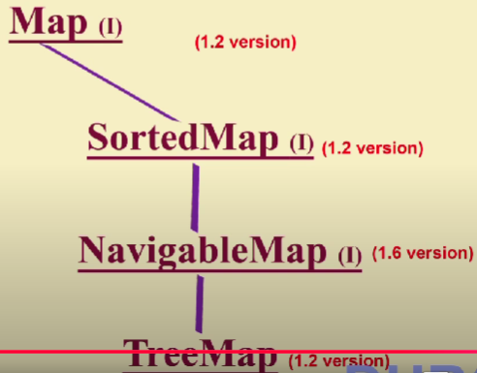

* **Hashtable (1.0v):**
* If you want old legacy object then you go for Hashtable.